Team UwU hardware design

**Email:** [**teamuwurobotics@gmail.com**](mailto:teamuwurobotics@gmail.com)

**Github:** [**https://github.com/Team-UwU-Robotics/Team-UwU**](https://github.com/Team-UwU-Robotics/Team-UwU)

**Information about the robot**

All of the parts are 3D printed to ensure that it is light and durable.

Omnidirectional robot - Robot travels in any angle

**Design Considerations**

The robot has to be lightweight and must be able to sustain a lot of crashes.

The electrical parts must not be in conflict with any of the robot parts - hence the usage of Fusion 360 to allow us to view the robot virtually before the parts are bought

The camera must be able to see the goals from anywhere on the field

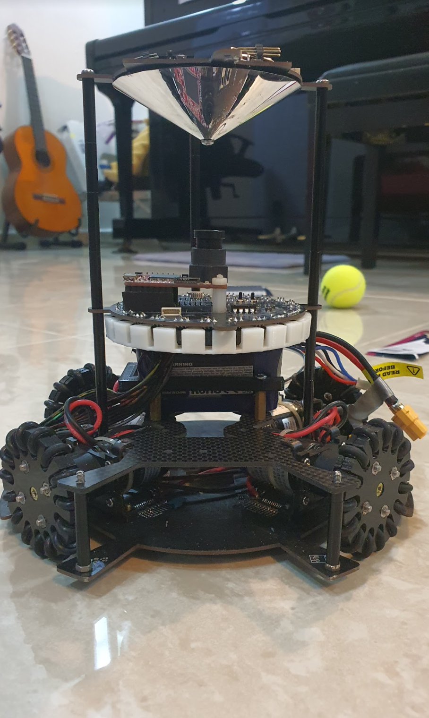

Figure 1: Front view of fully assembled robot

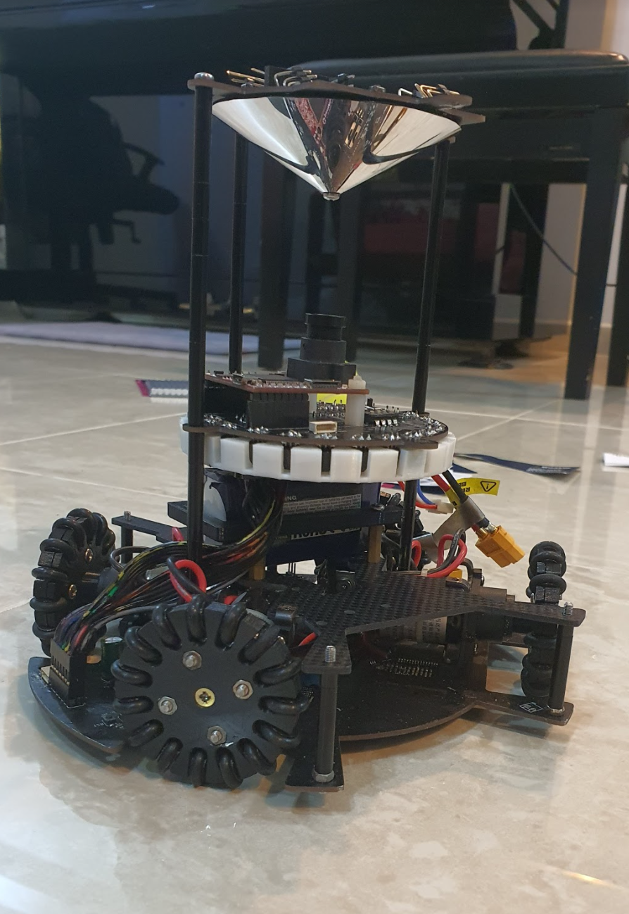

Figure 2: Front-right view of fully assembled robot

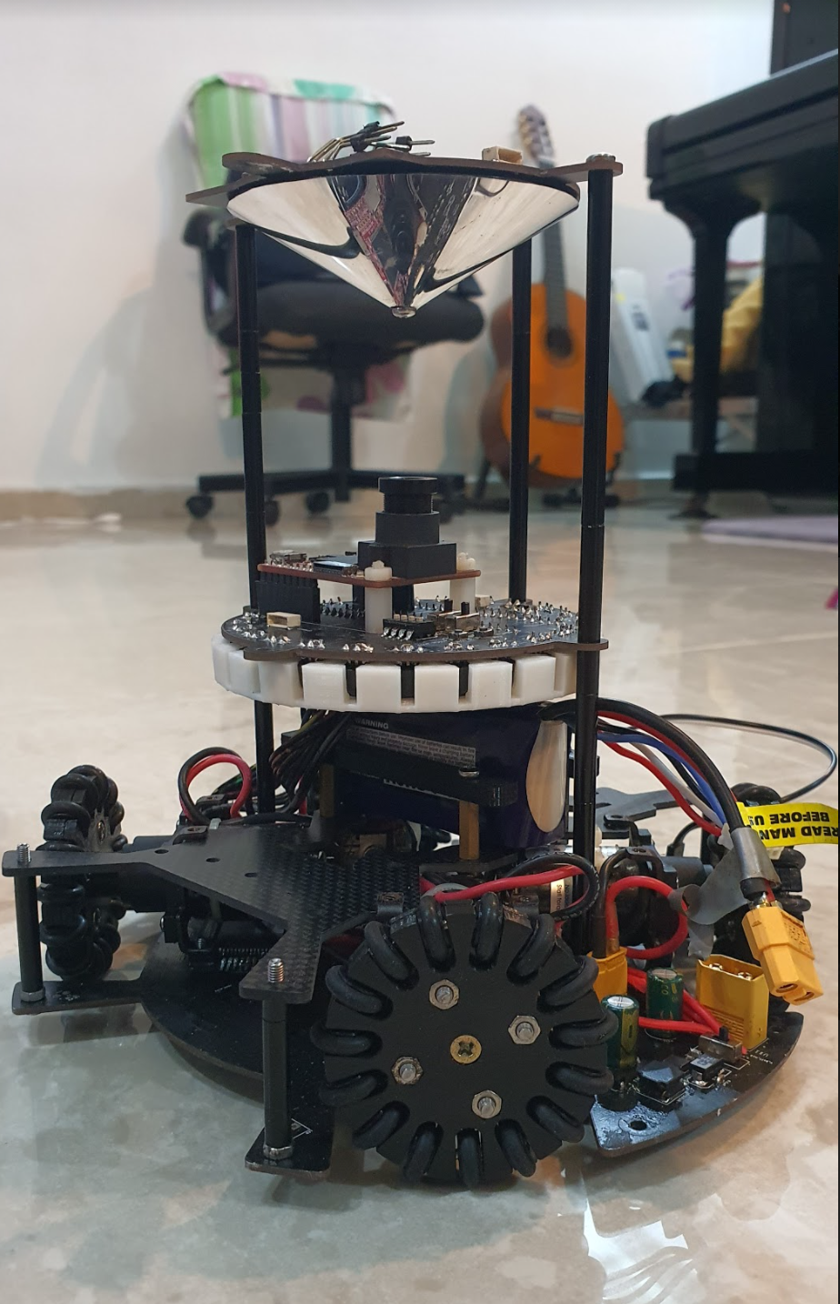

Figure 3: Front-left view of fully assembled robot

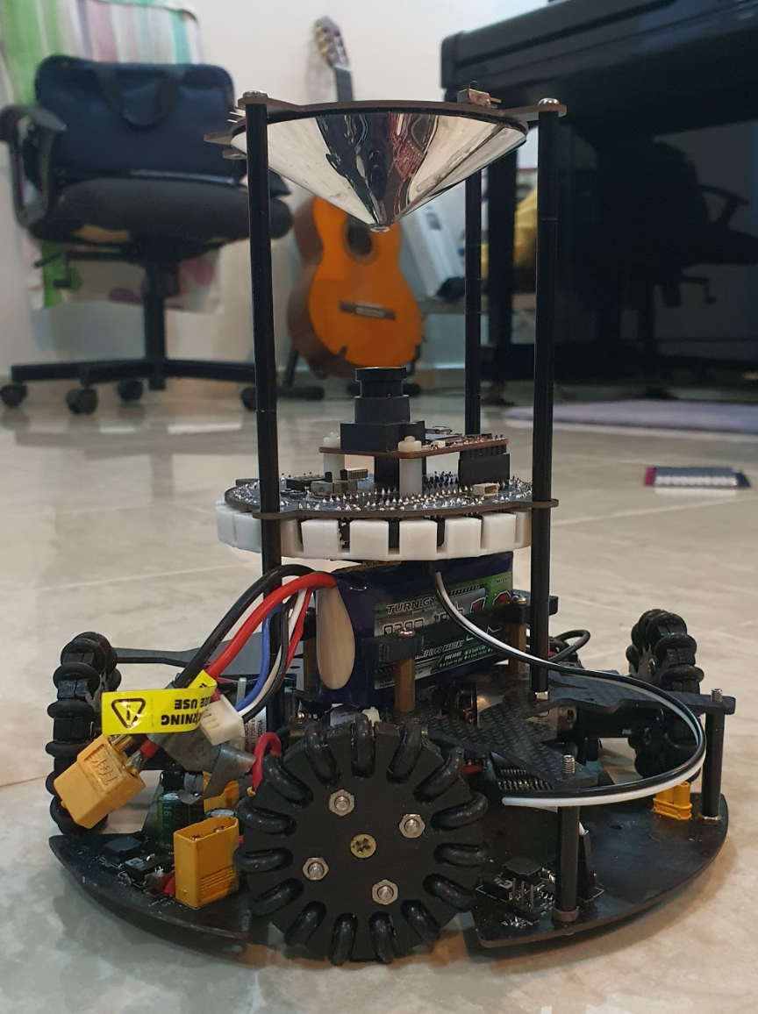

Figure 4: Back-left view of fully assembled robot

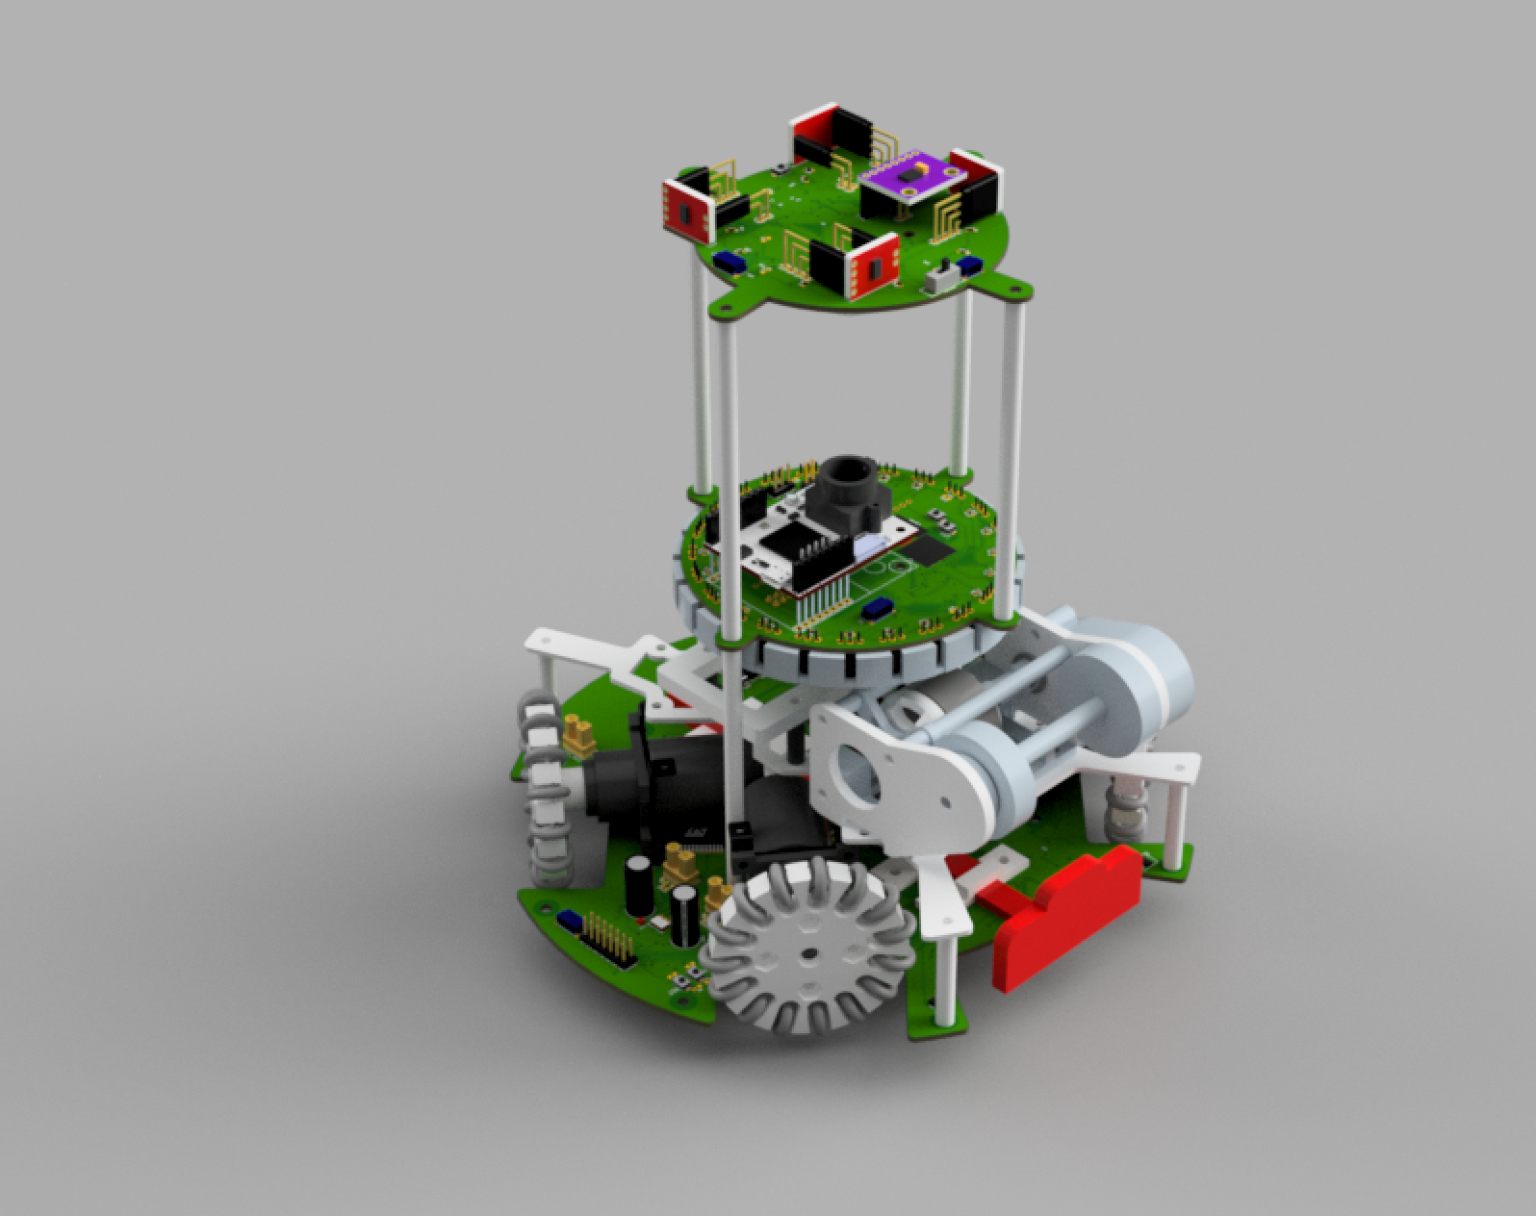

Figure 5: Diagonally-top view of 3D model

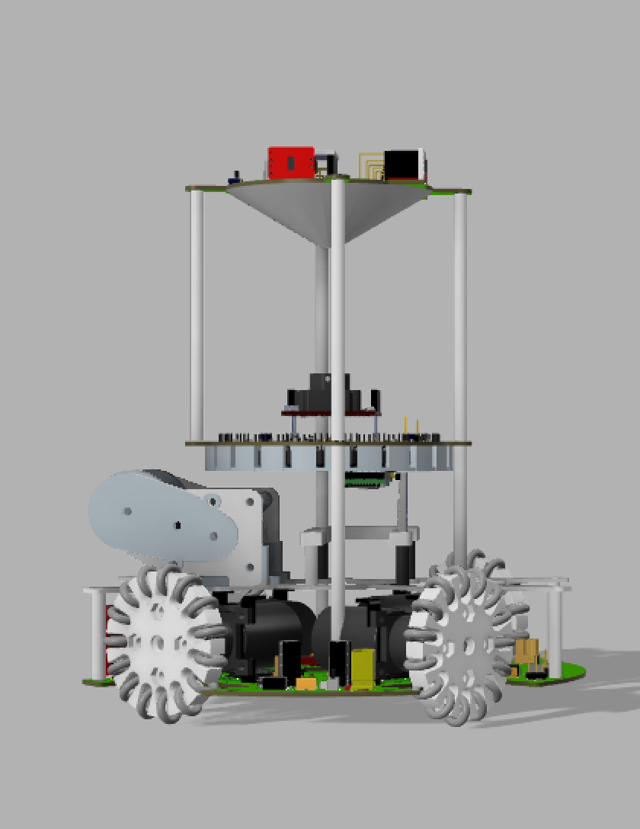

Figure 6: Right view of 3D model

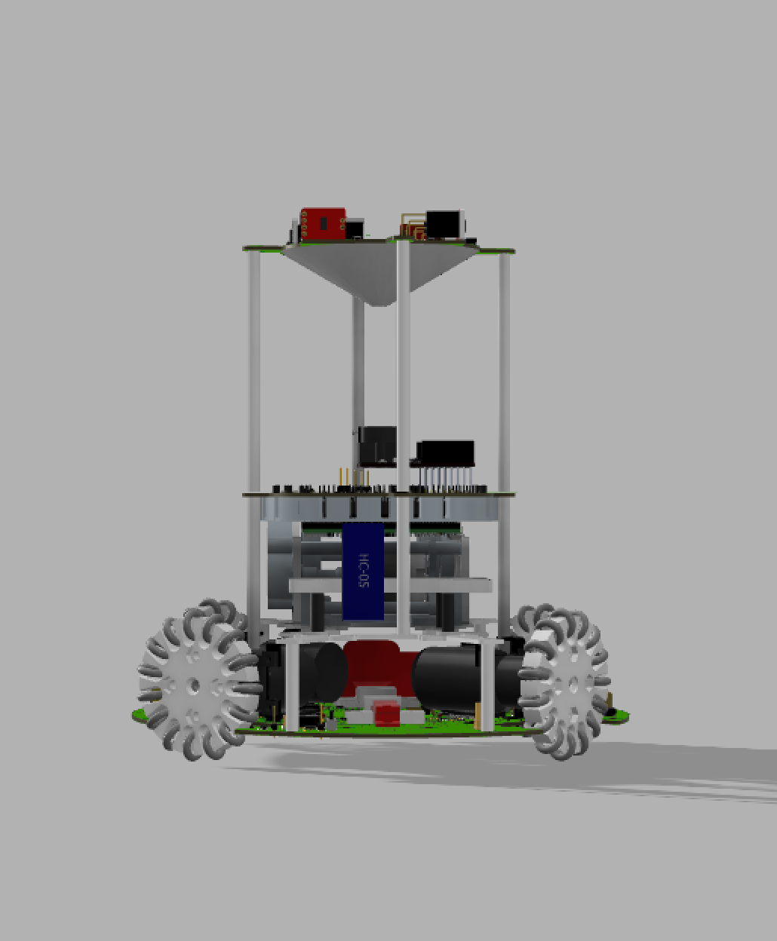

Figure 7: Back view of 3D model

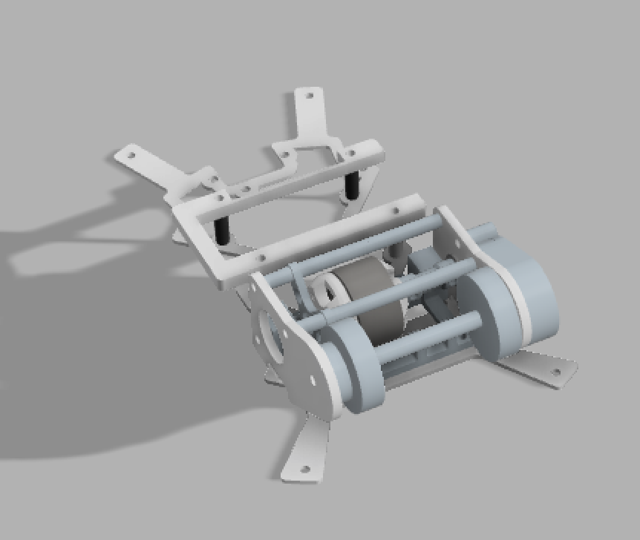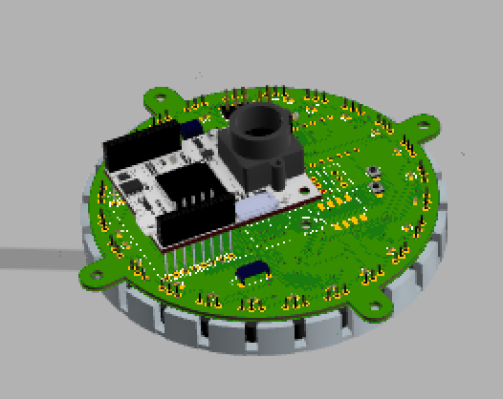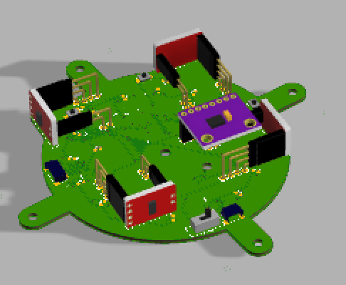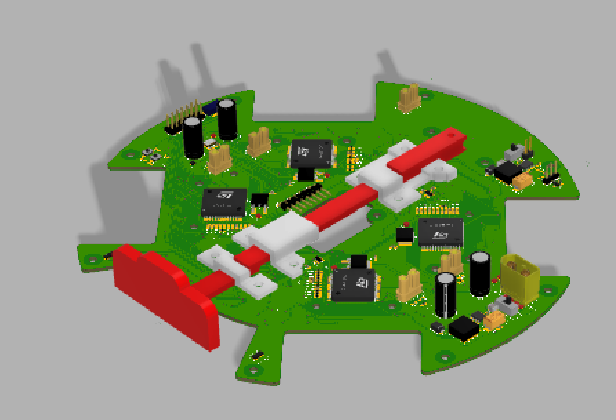

Figures 8-11Starting from top-left in a clockwise direction: Layer 1, Layer 2, Layer 3, Layer 4

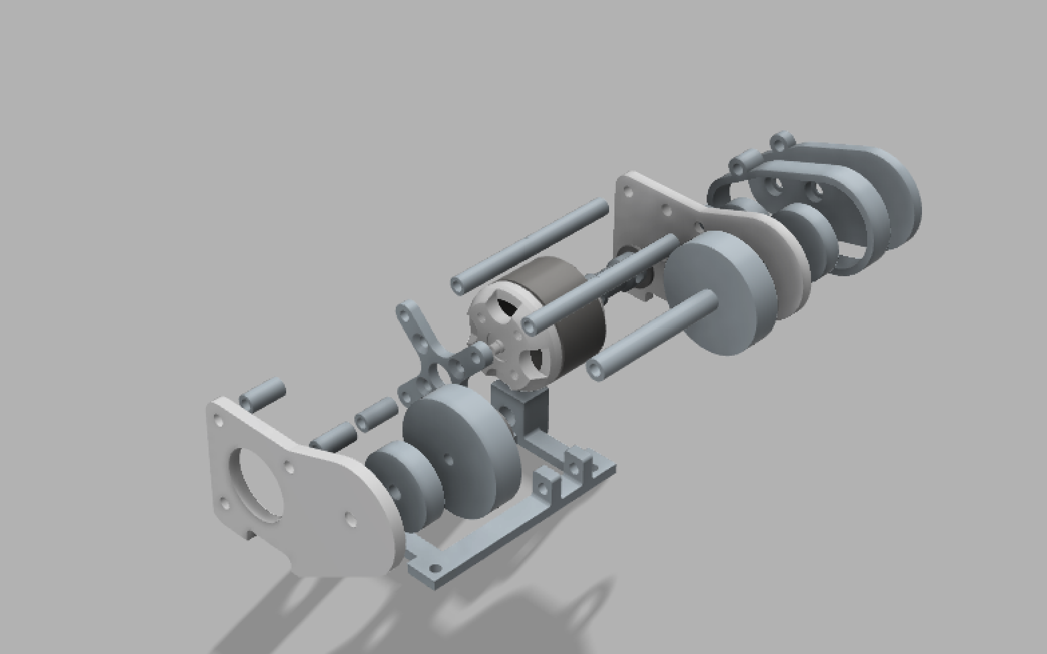

Figure 12: Exploded view of dribbler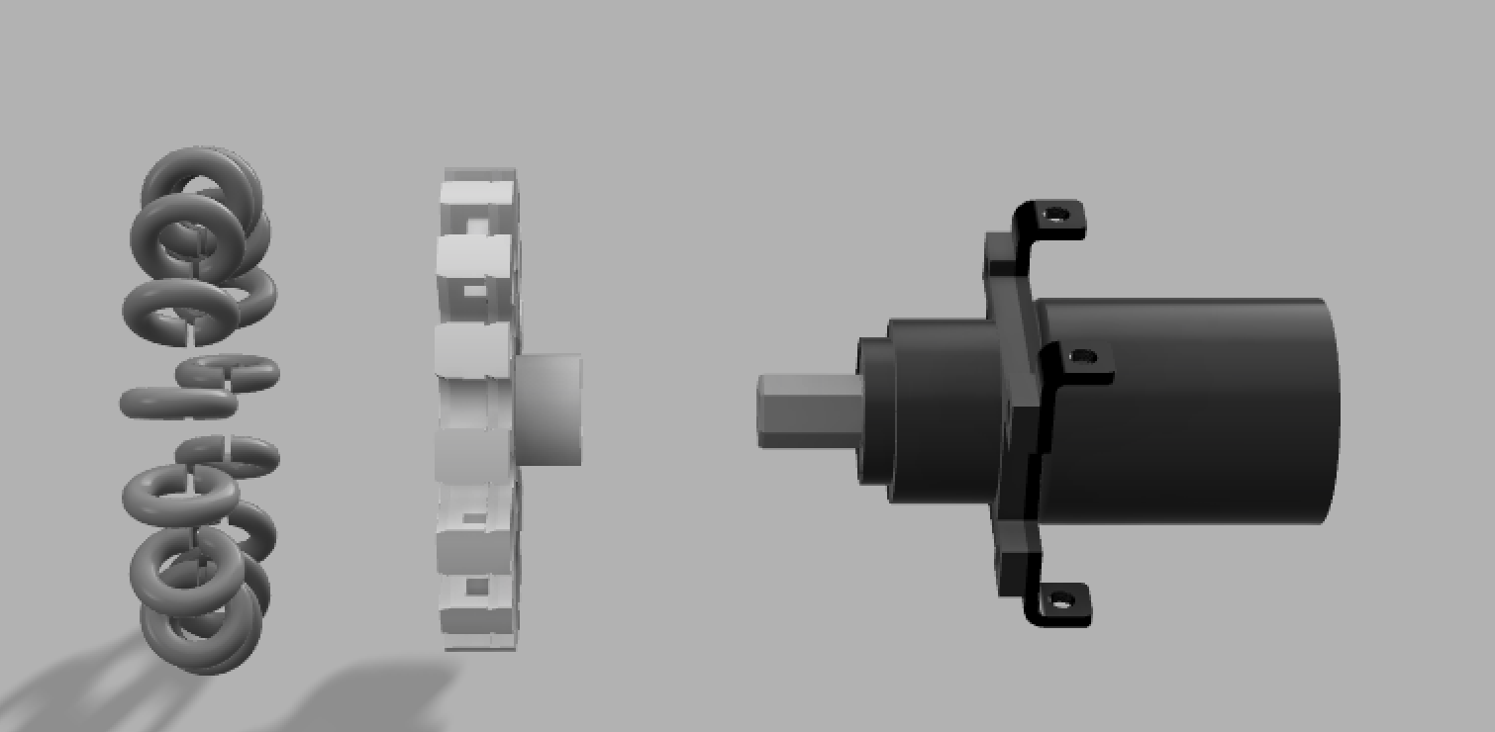

Figure 13: Exploded view of self-made omni-wheels

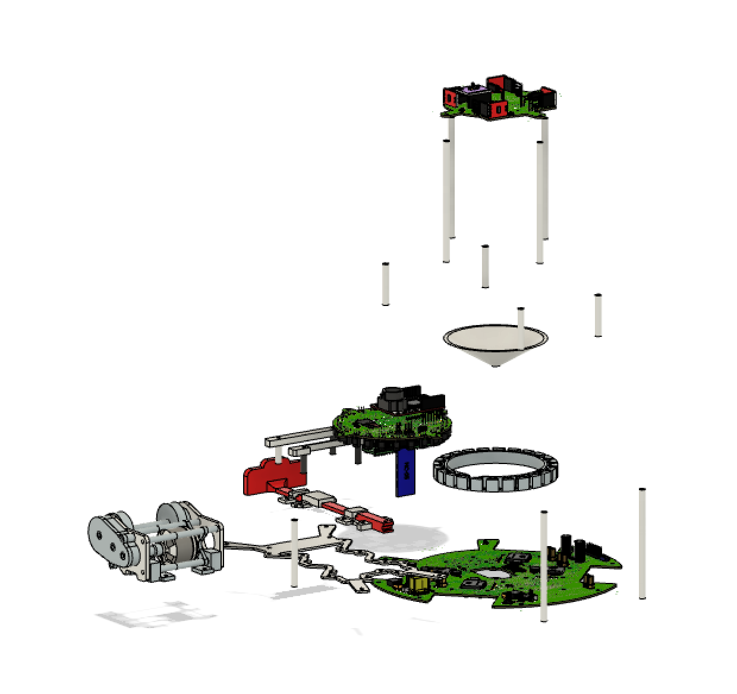

Figure 14: Exploded view of robot